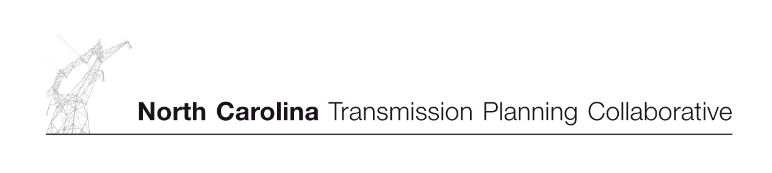

Form to Request a Local Economic Study

Date of Submittal
Submitting Company (TAG participant)
Company Contact
Contact Phone Number
Contact E-Mail Address
Sink
1. Specify the sink control area.
2. Specify LSE, if applicable.
Source
1. Specify the source control area.
2. Specify if the transaction is a system purchase or purchase from a specific generator(s). If from a specific generator(s), provide location of the generator for proper modeling. Attach interconnection one-line diagram as necessary.
Point-of-Receipt/Point-of Delivery Path:
(Examples: DEC/DEP; AEP/DEC; SCEG/DEP; SOCO/DEC)
Maximum Capacity in MW
Summer
Winter
Start date
End date, if applicable
Purpose and benefit for this study request.

Attach additional information as necessary.

