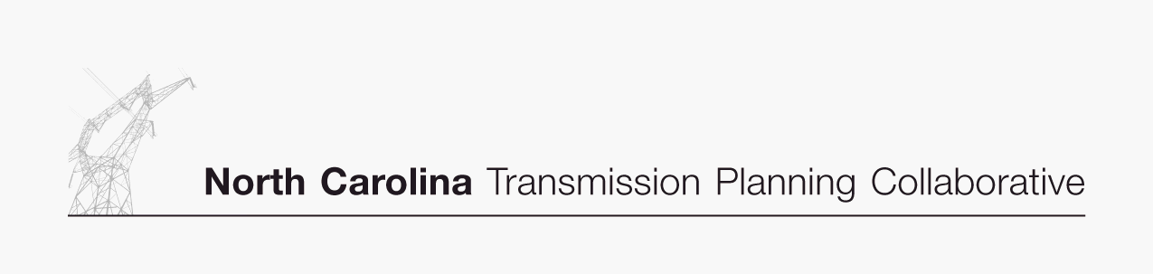

Transmission Advisory Group (TAG)
Agenda
April 23, 2009
North Carolina Electric Membership Corporation Office
3400 Sumner Boulevard
Raleigh, North Carolina
1:30 PM EDT

- Administrative Items
- Introductions
- Review meeting protocol and logistics
- Additional agenda items

- Enhanced Transmission Access Study Requests
- Receive report on the 2009 Enhanced Transmission Access Study Requests

- 2009 Study Activities
- Receive a progress report on the 2009 study scope and activities

- NCTPC TAG Sector Structure - Attachment K Compliance Filings
- Review and discuss the new TAG sector structure and voting protocol that was included in the Duke and Progress Attachment K compliance fillings in response to FERC Order 890

- Regional Studies
- Receive an update on various regional study activities

- 2009 TAG Work Plan
- Receive an update on and provide comments on the 2009 TAG work plan

- TAG Open Forum
- Discuss any items relevant to the NCTPC Process

