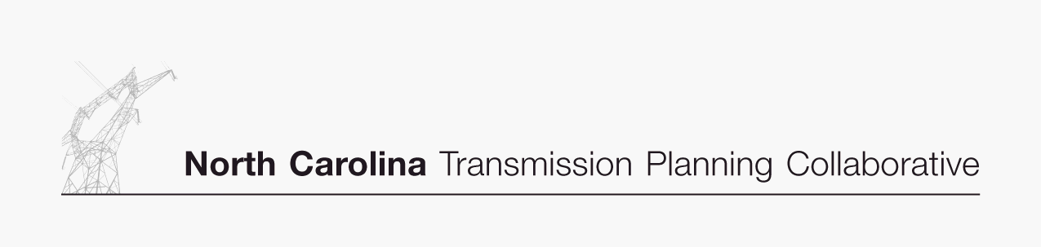

Transmission Advisory Group (TAG)
Agenda
December 4, 2008
North Carolina Electric Membership Corporation Office
3400 Sumner Boulevard
Raleigh, North Carolina
1:00 PM EDT

- Administrative Items
- Introductions
- Review meeting protocol and logistics
- Additional agenda items

- 2008 Study Final Results
- Receive a presentation and provide comments on the final results of the 2008 Study

- 2009 Study Scope
- Review and provide comments on the proposed 2009 study scope

- Duke and Progress Attachment K Compliance Filings
- Review and provide comments on the proposed changes to the Duke and Progress Attachment K compliance fillings in response to FERC Order 890

- Regional Studies
- Receive an update on various regional study activities

- 2009 TAG Work Plan
- Review and provide comments on the proposed 2009 TAG work plan

- TAG Open Forum
- Discuss any items relevant to the NCTPC Process

