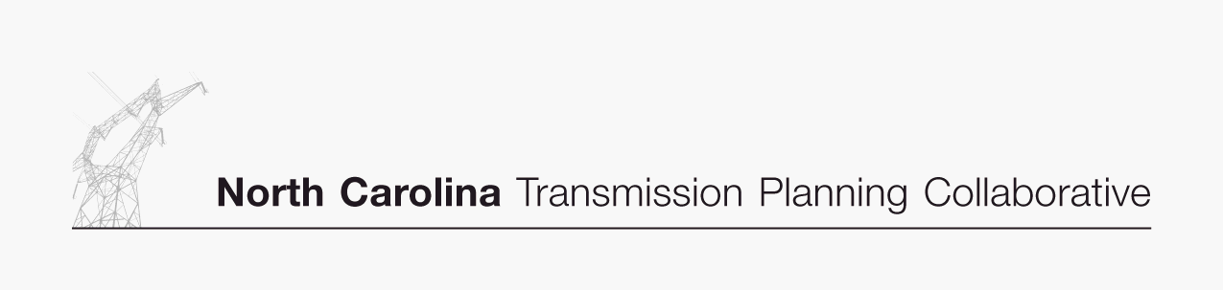

Transmission Advisory Group (TAG)
Agenda
September 18, 2008
North Carolina Electric Membership Corporation Office
3400 Sumner Boulevard
Raleigh, North Carolina
1:30 PM EDT

- Administrative Items
- Introductions
- Review meeting protocol and logistics
- Additional agenda items

- 2008 Study Scope and Status
- Review and update of the 2008 study scope and status of activities

- 2008 Study Preliminary Results
- Receive a progress report on the 2008 study preliminary results

- Major Transmission Project Update
- Receive a report on the progress of activities associated with major transmission projects

- Regional Studies
- Receive an update on various regional study activities

- 2008 TAG Work Plan
- Receive an update on the 2008 TAG work plan

- TAG Open Forum
- Discuss any items relevant to the NCTPC Process

