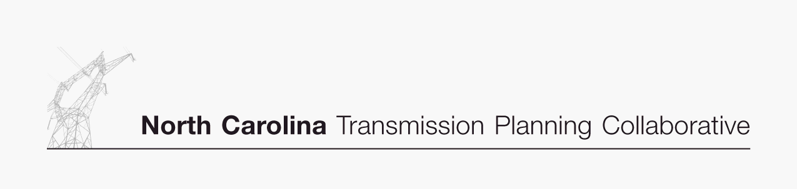

2007 Supplemental Report

Appendix B

Collaborative
Transmission
Plan
Major Project Descriptions

DRAFT - April 24, 2008
Project ID and Name: 0021 - Richmond-Ft Bragg Woodruff Street 230 kV Line

Project Description
Richmond-Ft Bragg Woodruff Street 230kV Line, Construct Line

Status
Transmission Owner | Progress
Planned In-Service Date | 06/01/2011
Estimated Time to Complete | 3.5 years
Estimated Cost | $85 million

Narrative Description of the Need for this Project
Construct a new 230 kV line approximately 65 miles in length, between PEC’s Richmond and Fort Bragg Woodruff Street 230 kV Substations. This project was developed to address the major loading issues associated with sitting a new combined cycle generator at PEC’s Richmond County Plant.
This project was developed to address loading issues on the following lines: Fayetteville-Fayetteville East 230kV, Fayetteville-Ft Bragg Woodruff St 230kV, Rockingham-Fayetteville 230kV, Richmond-Raeford 230kV, Richmond-Rockingham 230kV East, and Weatherspoon-Raeford 115kV.

Other Transmission Solutions Considered
Richmond-Raeford 230kV Line
Richmond-Fayetteville East 230kV Line
Richmond-Cumberland-Erwin 500kV Line

Why this Project was Selected as the Preferred Solution
This project was selected as the preferred solution since it was the best solution from a thermal loading perspective and was also the shortest route of the viable alternatives.

Project ID and Name: 0022 - Jacksonville Static VAR Compensator

Project Description
Jacksonville 230kV Substation, Install 300 MVAR 230kV SVC

Status
Transmission Owner | Progress
Planned In-Service Date | 06/01/2012
Estimated Time to Complete | 2 years
Estimated Cost | $30 million

Narrative Description of the Need for this Project
This project was identified during a dynamic evaluation of PEC’s East System during periods of increased imports. The dynamic studies that lead to the development of this project consisted of modeling induction motor loads then applying 3-phase faults on transmission lines in PEC East’s service territory. This analysis indicated that under certain faulted conditions that PEC East’s transmission network along the coast of North Carolina would be unable to maintain adequate voltage support. The lack of voltage support in the coastal area means that voltage recovery following certain faults is inadequate to maintain proper voltage. This means that induction motor loads will be unable to return to normal operation and that this portion of PEC East’s system will experience voltage instability.

Installing a 300 MVAR SVC at the Jacksonville 230kV Substation provides enough dynamic reactive support to allow the motors to accelerate to normal speed and to allow voltage to quickly recover to a normal operating level.

Other Transmission Solutions Considered
None

Why this Project was Selected as the Preferred Solution
This preferred solution was the only viable solution. Jacksonville 230kV Substation was selected as the ideal location to solve this problem due to the substation’s general location and network connectivity.

