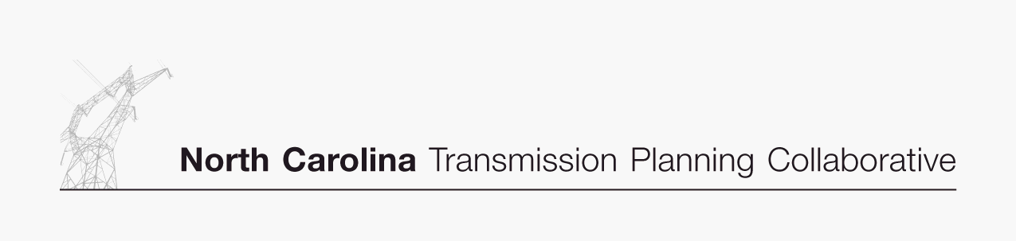

Appendix 3

Projects Investigated for Duke to Progress East Resource Supply Options Studied

DRAFT 03/22/07

Duke to Progress East Resources Supply Options – 600 MW and 1,200 MW Comparison – Study Year 2011
Primary Solution Alternative | Issue Identified | TO | Lead Time | Duke>PEC  600 MW  Need Date¹ | Nominal Cost  ($Millions)² | Duke>PEC  1,200 MW Need Date¹ | Nominal Cost  ($Millions)²
Fay-Ft. Bragg Woodruff St 230kV Line, Replace line switch (2014 TAP project-$250,000) | Fay-Ft. Bragg Woodruff St 230kV line, overload of existing line | Progress | 3 | 2012 | $0.05 | 2012 | $0.05
Wake 500 kV Sub, Install #3-500/230 kV bank (2017 - problem outside horizon, $21 M) | Wake 500/230 kV banks, overload of existing banks | Progress | 4 | 2014 | $21.00 | 2013 | $21.00
Fay-Fay East 230kV Line, Replace CB, wavetrap, line switches (2016 TAP project-$425,000) | Fay-Fay East 230kV line, overload of existing line | Progress | 3 | 2014 | $0.09 | 2014 | $0.09
Durham-RTP 230 kV , Reconductor line section (not needed in base case , $5 M) | Durham-RTP 230 kV line, overload of existing line | Progress | 4 | 2015 | $5.00 | 2014 | $5.00
Asheboro-Asheboro East 115 kV #3 , Construct new line (2015 TAP Project, $5 M) | Asheboro East-Asheboro 115 kV South and Asheboro East-Asheboro 115 kV North lines, one line overloads for the loss of the other | Progress | 5 | 2014 | $0.50 | 2013 | $1.00
Person-Milburnie 230 kV line, Uprate Rox Cog-Falls section ( 2017 - problem outside horizon, $2.5 M) | Person-Milburnie 230 kV line, overload of existing line | Progress | 3 | 2016 | $2.50 | 2015 | $2.50
West End 230 kV Sub, Install 230 kV reactor on Cape Fear terminal (2018 - problem outside horizon, $5 M) | Cape Fear - West End 230 kV and  Rockingham - West End 230 kV lines, overload of existing lines | Progress | 3 | 2016 | $5.00 | 2016 | $5.00
Rockingham-Lilesville 230 kV Line #3, Construct new line ( 2018 - problem outside horizon, $17.7 M) | Rockingham-Lilesville 230 kV Black & White lines, overload of existing lines | Progress | 5 | 2015 | $17.70 | 2011 | $17.70
Harrisburg-Oakboro 230 kV line 1/2 , Bundle line (not needed in base case, $3.0M) | Harrisburg-Oakboro 230 kV 1/2 lines, overload of existing lines | Duke | 3 | - | - | 2014³ | $3.00
Pleasant Garden 500/230 kV transformer - install additional capacity (not needed in base case, $16.0M) | Pleasant Garden 500/230 kV transformer, overload of existing bank | Duke | 5 | 2015 | $16.00 | 2014 | $16.00
 | TOTAL (Nominal Cost $Millions) |  |  |  | $67.84 |  | $71.34

- The table in Appendix 3 reflects the date the project is needed in order to implement the resource supply option studied.

- The table in Appendix 3 contains the estimated incremental costs of the transmission upgrades required to import an additional 600 MW or 1,200 MW into the Progress East system from Duke. The costs are incremental to the total transmission capital plans of Progress and Duke. Project costs represent either: (i) the estimated acceleration cost of an existing project within the 10-year planning horizon; or (ii) the estimated total cost of a new project that would be needed in the 10-year planning horizon to support the increased import. The costs are expressed in nominal dollars.

- The project date is based on Progress TRM case study results. Results based on Duke planning criteria result in a later project date.

