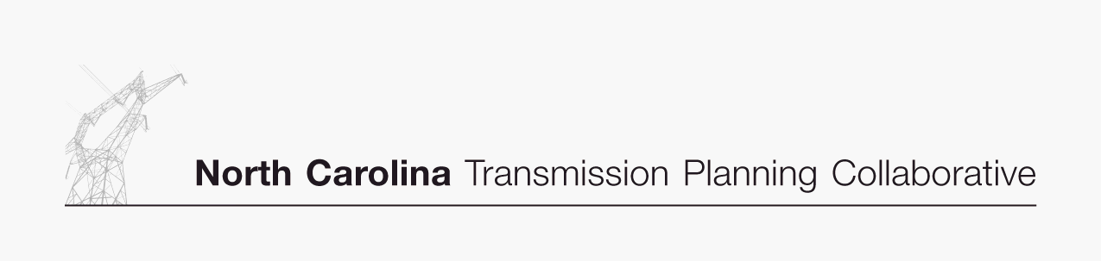

Appendix 2

Collaborative
Transmission
Plan
New and Modified
Major Project Descriptions

DRAFT 03/22/07
Project ID and Name: 0010A - Harris-RTP 230 kV Line

Project Description
Construct the Harris-RTP 230 kV Line. Develop RTP 230 kV Switching Substation at or near the existing Amberly 230 kV tap on the Cary Regency Park-Durham 230 kV line. Construct 7 miles of new 230 kV line between Amberly 230/23 kV and Green Level 115/23 kV using 6-1590 MCM ACSR and convert Green Level 115 kV Substation to 230/23 kV. Convert the existing Apex US 1– Green Level 115 kV Feeder (approximately 7 miles) to 230 kV using 6-1590 MCM ACSR and remove the termination at Apex US #1. From the termination point removed at Apex US #1, continue with 4 miles of new 230 kV construction to the Harris 230 kV Switchyard using 6-1590 MCM ACSR.

Status | Underway
Transmission Owner | Progress
Planned In-Service Date | 6/1/2011
Estimated Time to Complete | 4
Estimated Cost | $30 M

Narrative Description of the Need for this Project
This project is needed to serve rapidly growing load in the western Wake County area.

Transmission Solutions Considered
Establishing the Harris-Durham 230 kV line.

Why this Project was Selected as the Preferred Solution
Cost and feasibility.

Project ID and Name: 0010B - (PEC)Asheboro-(DE)Pleasant Garden
230kV Line, Replace Asheboro 230/115 kV
Transformers

Project Description
Construct the (PEC)Asheboro-(DE)Pleasant Garden 230 kV tie line between Progress Energy and Duke Energy. Construct 20 miles of new 230 kV line using 6-1590 MCM ACSR. At Asheboro 230 kV Substation replace 2-200MVA 230/115 kV transformers with 2-300 MVA 230/115 kV transformers.

 | Pleasant Garden-Asheboro 230 kV Line | Replace Asheboro  230/115 kV Transformers
Status | Planned | Planned
Transmission Owner | Progress/Duke | Progress
Planned In-Service Date | 6/1/2011 | 6/1/2011
Estimated Time to Complete | 5.0 years | 2.0 years
Estimated Cost | $25 M | $4 M

Narrative Description of the Need for this Project
To address contingency voltage issues in the Asheboro area, relieve loadings on the Biscoe/Asheboro and Tillery/Badin corridors and loading in the Raleigh/Durham area lines.

Transmission Solutions Considered
Parkwood-Durham 500 kV line, Harris-Durham 230 kV line, Cape Fear-Siler City 230 kV line, Buck-Asheboro 230 kV line.

Why this Project was Selected as the Preferred Solution
Defers the Cape Fear-Siler City 230 kV line beyond the 10 year planning horizon. Addresses several transmission issues including some that the Cape Fear-Siler City 230 kV line did not address. Cost same as Cape Fear-Siler City 230 kV line.

