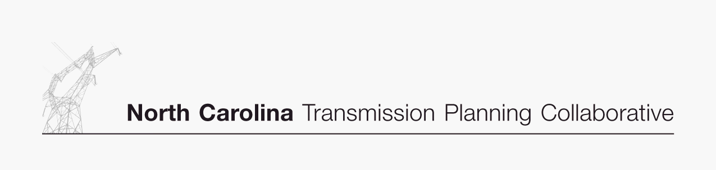

TO: Transmission Advisory Group (TAG)
FROM: Rich Wodyka
SUBJECT: TAG Meeting – RESCHEDULED to September 7th
DATE: July 11, 2006

The Oversight Steering Committee (OSC) of the North Carolina Transmission Planning Collaborative (NCTPC) was notified of a conflict with its scheduled August 2nd date for the next TAG meeting. As a result the OSC has decided to move the meeting from August 2nd to September 7th. The OSC apologizes for any inconvenience this may have caused to those that have already signed up for the August 2nd meeting.
The September 7th meeting will now be held at the ElectriCities office located at 1427 Meadow Wood Boulevard in Raleigh, NC. The meeting is scheduled to begin at 01:00 PM and conclude around 03:00 PM.
The purpose of the meeting is to inform the TAG of the progress associated with 2006 Reliability Planning Process. An agenda is being prepared and will be published at least ten days before the meeting date on the NCTPC website. An email message will be sent to you when the meeting agenda and any meeting materials are posted and available for your review.
If you are planning to attend this TAG meeting you must register at the NCTPC website ( www.nctpc.org/nctpc ). You register for this TAG meeting by selecting the “Register” button under the Next TAG Meeting Information area on the TAG activities page. If you have any questions or problems, please use the Contact Information feature on the NCTPC website.
If you are no longer interested in participating in this process and wish to be removed from the TAG distribution list, please use the Contact Information feature to let us know and we will remove you from the list.
The OSC and I are looking forward to your participation in this meeting.
Rich Wodyka

