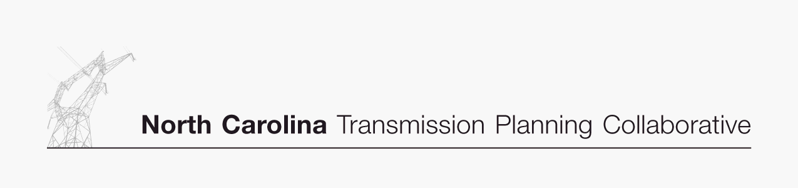

Transmission Advisory Group (TAG)
Agenda
September 7, 2006
ElectriCities Office
1427 Meadow Wood Boulevard
Raleigh, North Carolina
1:00 PM EDT

- Administrative Items
- Introductions
- Review meeting protocol and logistics
- Additional Agenda Items

- NC Transmission Planning Collaborative (NCTPC) Process
- Receive update from the OSC on the overall 2006 NCTPC Process

- Reliability Study and Preliminary Study Results
- Receive an update from the PWG on the current Reliability Study activities and the preliminary 2006 study results

- 2006 TAG Activity Schedule
- Receive an update on the 2006 TAG Activity Schedule

- TAG Open Forum
- Discuss any items relevant to the NCTPC Process

