DRAFT
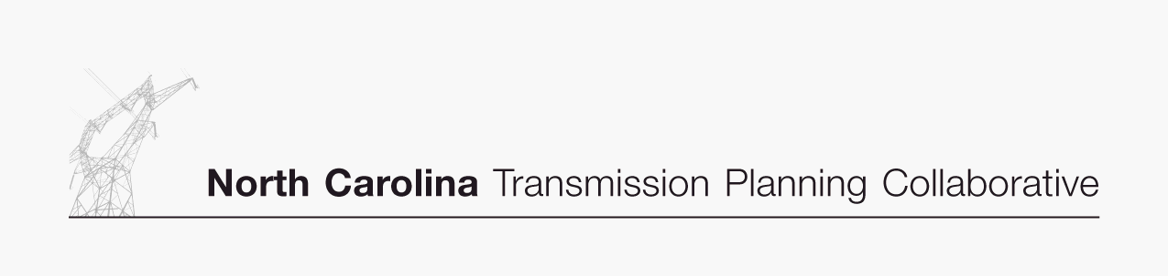
Transmission Advisory Group
Scope

Purpose
The Transmission Advisory Group (TAG) is formed from the North Carolina Load Serving Entities’ Transmission Planning Participation Agreement (“Agreement”) among the following Participants: Duke Power, Progress Energy Carolinas, Inc., North Carolina Electric Membership Corporation, and ElectriCities of North Carolina, Inc. The purpose of the TAG is to provide advice and recommendations to the Participants which will aid in the development of a single coordinated transmission plan for the respective service territories of these Participants in North Carolina.

Responsibilities
The TAG is responsible for working with the Participants to develop a transmission planning process that results in a single coordinated transmission plan which reliably and efficiently meets the needs of the electric consumers in North Carolina. The duties of this group include:
- Adhere to the intent of the FERC Standards of Conduct requirements in all discussions.
- Participate in the TAG meetings in a constructive and professional manner.
- Provide timely input on the issues associated with the development of the transmission planning process.
- Provide advice and recommendations to the Oversight Steering Committee of the Participants on the transmission plan results.

Membership
The TAG membership is open to all parties interested in the development of a coordinated transmission plan across the respective service territories of the Participants in North Carolina.

Meeting Procedures

Meeting Chair
The independent third-party consultant will chair the TAG meetings and serve as a facilitator for the group by working to bring consensus within the group. In addition, the duties of the independent third-party consultant include:
- Developing mechanisms to solicit and obtain the input of all market participants related to transmission planning options.
- Taking all reasonable action to ensure that no marketing / brokering organizations receive preferential treatment or achieve competitive advantage through the distribution of any transmission-related information in the TAG.
- Ensuring that confidentiality of information and Standards of Conduct requirements are being adhered to within the TAG process.
- Ensuring that TAG meeting notes are taken and meeting highlights are posted for the information of the participants after all TAG meetings.

Meeting Procedures

Meetings
Meetings of the TAG shall be open to all parties interested in the development of a coordinated transmission plan across the respective service territories of the Participants in North Carolina. There are no restrictions on the number of people attending TAG meetings from any organization.

Quorum

Since membership is open to all interested parties, there are no quorum requirements for TAG meetings.

Voting
In attempting to resolve any issue, the goal is for the TAG to develop consensus solutions. Non-binding straw votes may be taken by the TAG chair on issues or discussion items in order to get the sense of the group and attempting to achieve consensus. Only one vote for each organization participating in the TAG meeting will be allowed. Only organizations attending the meeting will be allowed to participate in the voting. No proxy votes will be allowed.

Meeting Protocol
In the absence of specific provisions in this document, the TAG shall conduct its meetings guided by the most recent edition of Robert’s Rules of Order, Newly Revised.

