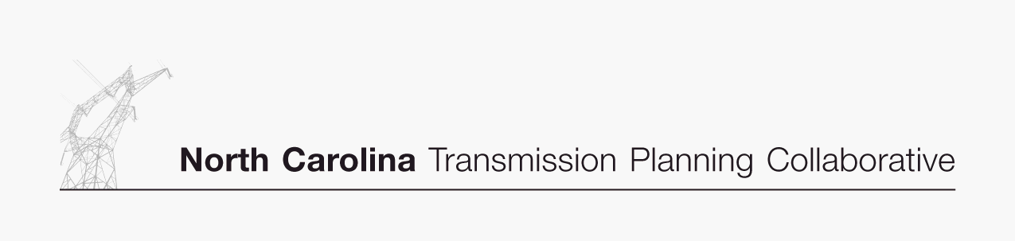
Transmission Advisory Group
2006 Activity Schedule

1st Quarter
- Receive update and provide comments on the NCTPC Process
- Provide comments on the Scope of TAG
- Review and comment on the 2006 TAG Activity Schedule
- Provide input to the OSC on proposed Enhanced Transmission Access scenarios and interfaces for study

2nd Quarter
- Receive OSC feedback on the Enhanced Transmission Access scenarios and interfaces selected for analysis in 2006
- Receive update on the Reliability Planning studies

3rd Quarter
- Review and comment on the Reliability Planning study results
- Receive update on the Enhanced Transmission Access Planning studies

4th Quarter
- Review and comment on the Enhanced Transmission Access Planning study results
- Review draft of final combined Collaborative Transmission Plan
- Provide feedback to the OSC on the 2006 NC TPC Process

