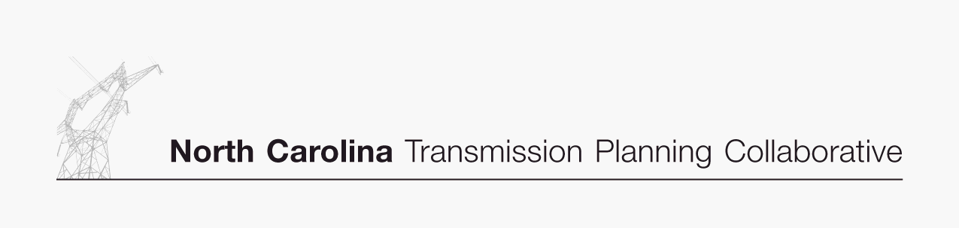

Transmission Advisory Group (TAG)
Agenda
February 3, 2006
ElectriCities Office
1427 Meadow Wood Boulevard
Raleigh, North Carolina
9:00 AM EPT

- Administrative Items
- Introductions
- Review meeting protocol and logistics
- Additional Agenda Items

- Scope of the Transmission Advisory Group
- Review and provide comments on the proposed Scope of TAG

- 2006 TAG Activity Schedule
- Review and provide comments on the proposed 2006 TAG Activity Schedule

- NC Transmission Planning Collaborative Process
- Receive update from the OSC on the overall NCTPC Process
- Review and provide comments on the NCTPC Process Document

BREAK

- Planning Process Status
- Receive an update from the PWG on the current Planning Process activities

- Enhanced Transmission Access Planning Process Input
- Discuss the requested input for transaction scenarios and interfaces for analysis in the Enhanced Transmission Access Planning Process
- Establish deadline for providing input to the OSC

- TAG Open Forum
- Discuss any items relevant to the NCTPC Process

