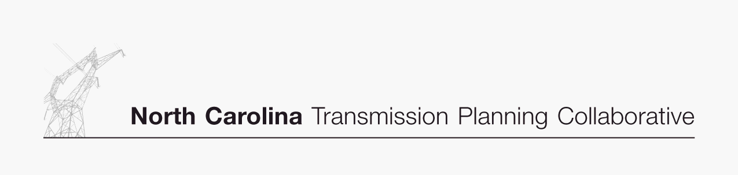

Appendix B

Collaborative Transmission
Plan
Major Project Listing

DRAFT 8/13/2007

Collaborative Transmission Plan (Continued) – Major Project Listing (Estimated Cost > $10M)
Project  ID | Reliability Project | Issue Resolved | Status¹ | Transmission  Owner | Projected In-Service Date | Estimated Cost  ($M) | Project Lead  Time (Years)
 | Lee Sub-Wommack 230 kV South Line, Reconductor | Address loading on Lee-Wommack 230 kV South line | Underway | Progress | 6/1/2008 | 13 | 0.5
 | Durham 500 KV Sub, Loop Mayo Plant-Wake 500 KV Line | Address loading on Wake 500/230 transformer banks | Underway | Progress | 6/1/2008 | 29 | 0.5
 | Durham-Falls 230 kV Line, Construct line | Address loading on Method-East Durham 230 kV line | Underway | Progress | 6/1/2008 | 10 | 0.5
 | Rockingham-West End 230 kV Line, Construct Wadesboro Bowman School 230 kV Tap, Uprate Line | Address loading on Rockingham-Blewett-Tillery 115 kV corridor | Underway | Progress | 6/12009 | 11 | 1.5
 | Clinton-Lee 230kV Line, Construct line | Address loading on Clinton-Vander 115 kV line & Lee Sub-Wallace 115 kV line | Underway | Progress | 6/1/2010 | 20 | 2.5
 | Greenville-Kinston Dupont 230 KV Line , Construct line | Address loading on Greenville-Everetts 230 kV Line | Underway | Progress | 6/1/2011 | 19 | 3.5
 | Rockingham - West End 230kV East Line, Construct Line | Address loading on Rockingham-West End 230 kV  Line | Underway | Progress | 6/1/2011 | 32 | 3.5
 | Cape Fear-Siler City 230 kV Line, Construct Line | Address voltage in the Asheboro area | Deferred² | Progress |  | 19
 | Richmond 500 kV Substation,  Install 500 kV series reactor in Richmond-  Newport 500 kV Line | Address large post contingency phase angle  differences at times of high 500 kV flow | Underway | Progress | 6/1/2009 | 10 | 1.5
 | Asheboro-(Duke Energy) Pleasant Garden 230 kV Line, Construct new line, at Asheboro Replace 2-200 MVA 230/115 kV Banks with 2-300 MVA Banks | Address loading on Badin-Tillery l00kV lines, Biscoe-Asheboro 115 kV line, Tillery-Biscoe 115 kV corridor, Newport-Richmond 500 kV line, Wake 500/230 banks | Underway | Progress | 6/1/2011 | 40 | 3.5
 | Harris Plant-RTP 230 kV Line, Establish a new 230 kV line by utilizing the Amberly 230kV Tap, converting existing Green Level 115kV Feeder to 230 kV operation, construction of new 230 kV line, remove 230/115 kV transformation and connection at Apex US1. | Address the need for new transmission source to serve rapidly growing load in the western Wake County area; helps address loading on Cary Regency Park-Durham 230 kV line | Underway | Progress | 6/1/2011 | 44 | 3.5
 | Rockingham-Lilesville 230 kV Line, Add third line | Address loading on Lilesville-Rockingham 230 kV lines | Underway | Progress | 6/1/2011 | 16 | 3.5
 | Wake 500 kV Sub, Add 3rd 500/230 kV Transformer Bank | Address loading on existing Wake 500/230 banks | Proposed | Progress | 6/1/2013 | 23 | 4.0
 | Cape Fear- West End 230 kV West Line, Install a 230 kV Series Reactor at West End 230 kV Sub | Address loading on Rockingham-West End 230 kV and Cape Fear-West End 230 kV lines | Proposed | Progress | 6/1/2016 | 12
 | Construct Ashville-Enka 115 kV Line | Address Asheville 230/115 kV transformer loading | Proposed | Progress | 12/1/2014 | 21
 | Reconductor Steelberry 230 kV Lines (Allen-Woodlawn #1 & #2) | Contingency loading of the remaining line on loss of the parallel line and Woodlawn 230/100/44 kV transformer when Allen 5 is off line. | Proposed | Duke | 2016 | $10 | 3
 | Replace Antioch 500/230 kV transformers #1 & #2 | Contingency loading of the remaining Antioch bank on loss of the parallel bank. | Proposed | Duke | 2013 | $30 | 5
 | Dooley Tie - new station at intersection of McGuire-Woodleaf 500 kV and Marshall-Winecoff 230 kV lines) with 500/230 kV transformer and reconductor of Dooley-Winecoff 230 kV lines | Contingency loading of the McGuire 500/230 kV bank on loss of the Godbey (Woodleaf-Pleasant Garden 500 kV) Line with McGuire Unit 1 off line (10 years). | Proposed | Duke | 2016 | $40 | 5
 | Reconductor Fisher 230 kV Lines (Central-Shady Grove Tap #1 & #2) | Contingency loading of the remaining line on loss of the parallel line when Cliffside 5 is off line. | Proposed | Duke | 2016 | $27 | 3
 | Reconductor London Creek 230 kV Lines  (Peach Valley-Riverview #1 & #2) | Contingency loading of the remaining line on loss of the parallel line when an Oconee unit is off line | Proposed | Duke | 2020 | $25 | 3

1Status:

Underway: Projects with this status range from the Transmission Owner having some money in its current year budget for the project to the Transmission Owner having completed some construction
activities for the project.
Planned: Projects with this status do not have money in the Transmission Owner’s current year budget; and the project is subject to change

2
Project was deferred last year to the end of the planning horizon.

