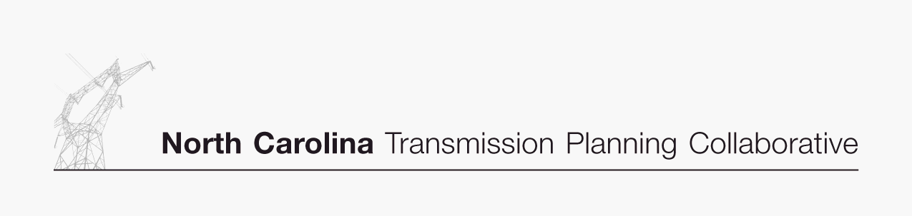

Appendix B

Collaborative Transmission
Plan
Major Project Listing

DRAFT 7/31/07

Collaborative Transmission Plan (Continued) – Major Project Listing (Estimated Cost > $10M)
Project  ID | Reliability Project | Issue Resolved | Status¹ | Transmission  Owner | Projected In-Service Date | Estimated Cost  ($M) | Project Lead  Time (Years)
 | Reconductor Steelberry 230 kV Lines (Allen-Woodlawn #1 & #2) | Contingency loading of the remaining line on loss of the parallel line and Woodlawn 230/100/44 kV transformer when Allen 5 is off line. | Proposed | Duke | 2016 | $10 | 3
 | Replace Antioch 500/230 kV transformers #1 & #2 | Contingency loading of the remaining Antioch bank on loss of the parallel bank. | Proposed | Duke | 2013 | $30 | 5
 | Dooley Tie - new station at intersection of McGuire-Woodleaf 500 kV and Marshall-Winecoff 230 kV lines) with 500/230 kV transformer and reconductor of Dooley-Winecoff 230 kV lines | Contingency loading of the McGuire 500/230 kV bank on loss of the Godbey (Woodleaf-Pleasant Garden 500 kV) Line with McGuire Unit 1 off line (10 years). | Proposed | Duke | 2016 | $40 | 5
 | Reconductor Fisher 230 kV Lines (Central-Shady Grove Tap #1 & #2) | Contingency loading of the remaining line on loss of the parallel line when Cliffside 5 is off line. | Proposed | Duke | 2016 | $27 | 3
 | Reconductor London Creek 230 kV Lines  (Peach Valley-Riverview #1 & #2) | Contingency loading of the remaining line on loss of the parallel line when an Oconee unit is off line | Proposed | Duke | 2020 | $25 | 3

- Status: In Service – transmission facility is commissioned and in service.

Under Construction – the transmission owner has completed Right of Way (“ROW”) acquisition, siting and permitting; the transmission owner is in the process of ordering equipment and hiring a contractor; or the transmission facility is actually under construction.

Committed – the project has some money in the transmission owner’s budget for the current fiscal year for ROW acquisition, detailed design, surveys, geotechnical studies, siting and permitting efforts.

Planned – the project is (i) within the first 5 year window or (ii) within the 10 year planning horizon and the project has a longer lead time that would require spending in the near term to be completed in time to address the reliability issue. However, the project is not in the transmission owner’s budget for the current fiscal year yet. The project is subject to change, but, there is more confidence in the implementation of the planned project than in a proposed or conceptual project.

Proposed – the project is within the 6-10 year window of the 10 year planning horizon and is not budgeted yet, and is subject to significant change.

Concept – the project is a high level concept for addressing issues related to resource supply options, or issues beyond the 10 year planning horizon.

