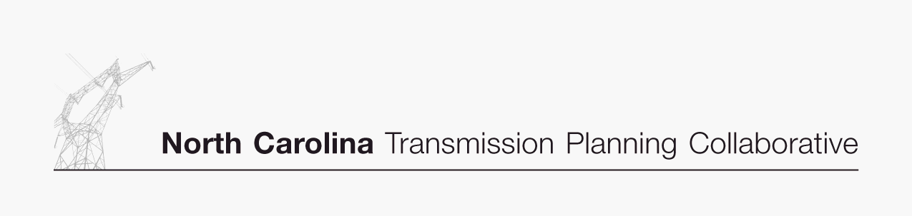

DRAFT

Transmission Advisory Group (TAG)
Agenda
December 9, 2009
North Carolina Electric Membership Corporation Office
3400 Sumner Boulevard
Raleigh, North Carolina
1:30 PM EDT

- Administrative Items
- Introductions
- Review meeting protocol and logistics
- Additional agenda items

- 2009-2019 Collaborative Plan DRAFT Report
- Receive a presentation and provide comments on the 2009-2019 Collaborative Plan DRAFT Report 009 Study

- 2010 Study Scope
- Review and provide comments on the proposed 2010 study scope

- Regional Studies
- Receive an update on various regional study activities

- 2009 TAG Work Plan
- Review and provide comments on the proposed 2010 TAG work plan

- TAG Open Forum
- Discuss any items relevant to the NCTPC Process

