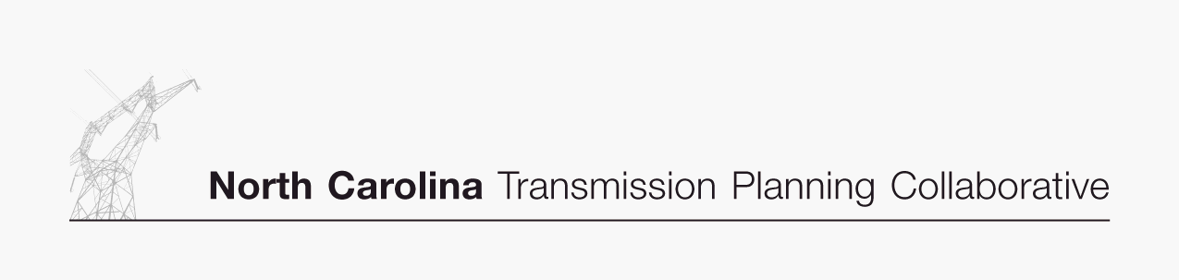

Appendix D

Projects Investigated for Resource Supply Options Studied

January 8, 2008
Resource Supply Options – 2016 Hypothetical Import Scenarios Studied
Imports to Progress East
Primary Alternative Investigated | Issue Identified | TO | Lead Time  (years) | Duke  600 MW  Date Needed ($M) |  | Duke  1,200 MW  Date Needed ($M) |  | PJM  200 MW  Date Needed ($M) |  | SCPSA  400 MW  Date Needed ($M) |  | SCEG  600 MW  Date Needed ($M)
N/A | None. | --- | --- | --- | --- | --- | --- | --- | --- | --- | --- | --- | ---

Resource Supply Options – 2016 Hypothetical Import Scenarios Studied
Imports to Duke
Primary Alternative Investigated | Issue Identified | TO | Lead Time  (years) | CPLE  100 MW  Date Needed ($M) |  | SOCO  600 MW  Date Needed ($M) |  | PJM  600 MW  Date Needed ($M) |  | TVA  600 MW  Date Needed ($M) |  | SCEG  600 MW  Date Needed ($M)
N/A | None. | --- | --- | --- | --- | --- | --- | --- | --- | --- | --- | --- | ---

Resource Supply Options – 2016 Hypothetical Generation Scenarios Studied
In Progress East^{1,2}
Primary Alternative Investigated | Issue Identified | TO | Lead Time  (years) | Scotland County  450 MW  Date Needed ($M) |  | Cumberland County  450 MW  Date Needed ($M) |  | Wilson County  450 MW  Date Needed ($M) |  | Johnston County  450 MW  Date Needed ($M) |  | Robeson County  600 MW  Date Needed ($M)
Construct Weatherspoon-Cumberland 230 kV line and Cumberland-Fayetteville East 230 kV line | Thermal loadings on Fayetteville-Fayetteville East 230 kV line and Weatherspoon Plant-Fayetteville DuPont 115 kV line | Progress | 5 | --- | --- | --- | --- | --- | --- | --- | --- | 2016 | 65
Install 115 kV series reactor on Weatherspoon Plant-Fayetteville Dupont 115 kV line and Weatherspoon-Raeford 115 kV line | Thermal load on Weatherspoon-Raeford 115 kV line | Progress | 4 | --- | --- | --- | --- | --- | --- | --- | --- | 2016 | 5
Install 115 kV series reactor at Weatherspoon on Wagram 115 kV terminal | Thermal loading on Raeford-Wagram 115 kV line | Progress | 4 | 2016 | 2 | --- | --- | --- | --- | --- | --- | --- | ---

Resource Supply Options – 2016 Hypothetical Generation Scenarios Studied
In Duke
Primary Alternative Investigated | Issue Identified | TO | Lead Time  (years) | Guilford County  150 MW  Date Needed ($M) |  | Davidson County  150 MW  Date Needed ($M) |  | Union County  150 MW  Date Needed ($M) |  | Gaston County  150 MW  Date Needed ($M) |  | Rockingham County  800 MW  Date Needed ($M)
N/A | None. | --- | --- | --- | --- | --- | --- | --- | --- | --- | --- | --- | ---

The tables in Appendix D reflect the date the project is needed in order to implement the resource supply option studied.

² The estimated cost is in nominal dollars which reflects the sum of the estimated annual cash flows over the expected development period for the specific project (typically 2 – 5 years), including direct costs, loadings and overheads; but not including AFUDC.
Each year’s cash flow is escalated to the year of the expenditures. The sum of the expected cash flows is the estimated cost. Also, the projects required to accommodate each resource supply option were determined independently. Therefore, the projects
and cost estimates do not reflect the requirements for simultaneously accommodating two or more resource supply options.

