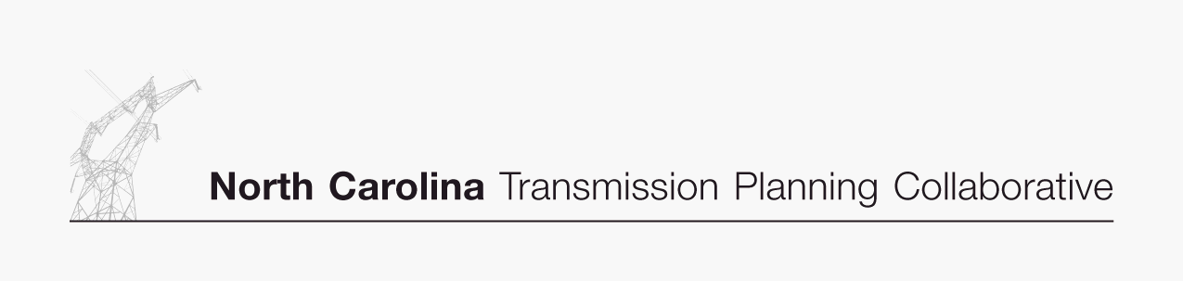

Appendix B

Collaborative Transmission
Plan
Major Project Listing

January 8, 2008

Collaborative Transmission Plan – Major Project Listing (Estimated Cost > $10M)¹
Project  ID | Reliability Project | Issue Resolved | Status² | Transmission  Owner | Projected In-Service Date | Estimated Cost  ($M)³ | Project Lead  Time (Years)⁴
0001 | Marion-Whiteville 230 kV Line,  Establish a new 230 kV line initially operated at  115 kV | Address loading on Marion-Whiteville 115 kV | In-service on 6/7/2007 | Progress | n/a | 10 | n/a
0002 | Lee Sub-Wommack 230 kV South Line, Reconductor | Address loading on Lee-Wommack 230 kV South line | Underway | Progress | 6/1/2008 | 13 | 0.5
0003 | Durham 500 KV Sub, Loop Mayo Plant-Wake 500 KV Line | Address loading on Wake 500/230 transformer banks | Underway | Progress | 6/1/2008 | 29 | 0.5
0017 | Durham-Falls 230 kV Line, Construct line | Address loading on Method-East Durham 230 kV line | Underway | Progress | 6/1/2008 | 10 | 0.5
0005 | Rockingham-West End 230 kV Line, Construct Wadesboro Bowman School 230 kV Tap, Uprate line | Address loading on Rockingham-Blewett-Tillery 115 kV corridor | Underway | Progress | 6/1/2009 | 11 | 1.5
0007 | Richmond 500 kV Substation,  Install 500 kV series reactor in Richmond-  Newport 500 kV Line | Address large post contingency phase angle  differences at times of high 500 kV flow | Underway | Progress | 12/1/2009 | 10 | 1.5
0004 | Clinton-Lee 230kV Line, Construct line | Address loading on Clinton-Vander 115 kV line & Lee Sub-Wallace 115 kV line | Underway | Progress | 6/1/2010 | 21 | 2.5
0011 | Asheville-Enka,  Convert 115 kV Line to 230 kV,  Construct new 115 kV line | Address Asheville 230/115 kV transformer loading | Planned | Progress | 12/1/2010  12/1/2012 | 28 | 3.0  5.0

Collaborative Transmission Plan – Major Project Listing – Continued (Estimated Cost > $10M)¹
Project  ID | Reliability Project | Issue Resolved | Status² | Transmission  Owner | Projected In-Service Date | Estimated Cost  ($M)³ | Project Lead  Time (Years)⁴
0008 | Greenville-Kinston Dupont 230 KV Line , Construct line | Address loading on Greenville-Everetts 230 kV Line | Underway | Progress | 6/1/2011 | 19 | 3.5
0010 | Rockingham-West End 230kV East Line, Construct line | Address loading on Rockingham-West End 230 kV  Line | Underway | Progress | 6/1/2011 | 32 | 3.5
0010A | Harris Plant-RTP 230 kV Line, Establish a new 230 kV line by utilizing the Amberly 230kV Tap, converting existing Green Level 115kV Feeder to 230 kV operation, construction of new 230 kV line, remove 230/115 kV transformation and connection at Apex US1 | Address the need for new transmission source to serve rapidly growing load in the western Wake County area; helps address loading on Cary Regency Park-Durham 230 kV line | Underway | Progress | 6/1/2011 | 46 | 3.5
0010B | Asheboro-Pleasant Garden 230 kV Line, Construct new line, at Asheboro replace 2-200 MVA 230/115 kV Banks with 2-300 MVA Banks | Address loading on Badin-Tillery l00kV lines, Biscoe-Asheboro 115 kV line, Tillery-Biscoe 115 kV corridor, Newport-Richmond 500 kV line, Wake 500/230 banks | Underway | Progress  &  Duke | 6/1/2011 | 40 | 3.5
0018 | Rockingham-Lilesville 230 kV Line, Add third line | Address loading on Lilesville-Rockingham 230 kV lines | Underway | Progress | 6/1/2011 | 16 | 3.5
0016 | Wake 500 kV Sub, Add 3rd 500/230 kV Transformer Bank | Address loading on existing Wake 500/230 banks | Planned | Progress | 6/1/2013 | 23 | 4.0
0019 | Cape Fear-West End 230 kV West Line, Install a 230 kV Series Reactor at West End 230 kV Sub | Address loading on Rockingham-West End 230 kV and Cape Fear-West End 230 kV lines | Planned | Progress | 6/1/2016 | 12 | 4.0

Collaborative Transmission Plan – Major Project Listing – Continued (Estimated Cost > $10M)¹
Project  ID | Reliability Project | Issue Resolved | Status² | Transmission  Owner | Projected In-Service Date | Estimated Cost  ($M)³ | Project Lead  Time (Years)⁴
0013 | Replace Antioch 500/230 kV transformers #1 & #2 | Contingency loading of the remaining Antioch bank on loss of the parallel bank | Planned | Duke | 2013 | 51.9 | 5
0020 | Reconductor Fisher 230 kV Lines (Central-Shady Grove Tap #1 & #2) | Contingency loading of the remaining line on loss of the parallel line when Cliffside 5 is off line | Planned | Duke | 2016 | 28.5 | 3
0014 | Reconductor London Creek 230 kV Lines  (Peach Valley-Riverview #1 & #2) | Contingency loading of the remaining line on loss of the parallel line when an Oconee unit is off line | Deferred | Duke

¹ The Henderson-Kerr Dam 115 kV Line was listed in the 2006 Supplemental Report with an estimated cost of $10 million or more. The 2007 Study results continue to identify the need for the project,
but the project is not listed in the 2007 Collaborative Transmission Plan since the estimated cost is now less than $10 million.

² Status:

In-service: Projects with this status are in-service.
Underway: Projects with this status range from the Transmission Owner having some money in its current year budget for the project to the Transmission Owner having completed some construction
activities for the project.
Planned: Projects with this status do not have money in the Transmission Owner’s current year budget; and the project is subject to change.
Deferred: Projects with this status were identified in the 2006 Supplemental Report and have been deferred beyond the end of the planning horizon based on analysis performed to develop the 2007
Collaborative Transmission Plan.

³ The estimated cost is in nominal dollars which reflects the sum of the estimated annual cash flows over the expected development period for the specific project (typically 2 – 5 years), including direct costs,
loadings and overheads; but not including AFUDC. Each year’s cash flow is escalated to the year of the expenditures. The sum of the expected cash flows is the estimated cost.

⁴ For projects with a status of Underway, the project lead time is the time remaining to complete construction and place in-service.

