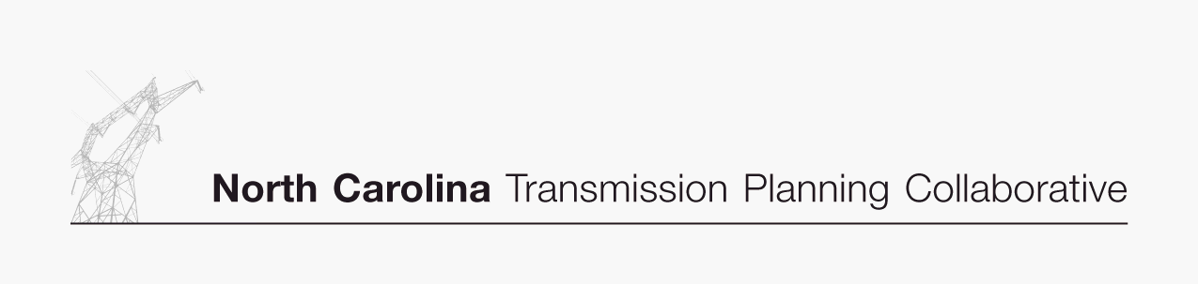

NCTPC
Update on
Major Projects

06/18/07
NCTPC Update on Major Projects (Estimated Cost > $10M)
Project  ID | Reliability Project | Issue Resolved | Status | Transmission  Owner | Planned In-Service Date
0001 | Marion-Whiteville 230 kV Line,  Establish a new 230 kV line initially operated at 115 kV | Address loading on Marion-Whiteville 115 kV | Line was energized at 115kV on 6/7/07. Line will be converted to 230kV operation in 2008. | Progress | 6/1/2007
0002 | Lee Sub-Wommack 230 kV South Line, Reconductor existing line | Address loading on Lee-Wommack 230 kV South Line | Project is on schedule. Construction is approximately 60% complete. | Progress | 5/1/2008
0003 | Durham 500 kV Sub,  Establish 500 kV at Durham & loop-in the Mayo Plant-Wake 500 kV Line | Address loading on Wake 500/230 kV transformers | Project is on schedule. Substation construction is underway with relay construction scheduled to begin in July 2007. | Progress | 6/1/2008
0004 | Clinton-Lee 230 kV Line,  Construct new line | Address loading on Clinton-Vander 115 kV line & Lee Sub-Wallace 115 kV Line | Contingency loading in recent studies has been lower than in previous studies allowing for this project to be delayed one year to 2010. | Progress | 6/1/2010
0005 | Rockingham-West End 230 kV Line,  Construct Wadesboro Bowman School 230 kV Tap & uprate the portion between the tap & Rockingham 230 kV Sub | Address loading on Rockingham-Blewett-Tillery 115 kV corridor | Project is on schedule. Right-of-way acquisition is approximately 90% complete. Clearing will begin in fall 2007. | Progress | 6/1/2009
0007 | Richmond 500 kV Substation,  Install 500 kV series reactor in Richmond-Newport 500 kV Line | Address large post contingency phase angle differences at times of high 500 kV flow | Conceptual design is nearing completion. | Progress | 6/1/2010
0008 | Greenville-Kinston Dupont 230 kV Line,  Construct new 230 kV line | Address loading on Greenville-Everetts 230 kV Line | All right-of-way has been acquired. | Progress | 6/1/2011
0009 | Henderson-Kerr Dam 115 kV Line,  Construct new Warrenton 115 kV Tap & add line switches providing alternate service to Warrenton area | Address voltage in Warrenton area | Project is on schedule. Survey is complete, right-of way acquisition is underway. | Progress | 6/1/2011
0010 | Rockingham-West End 230 kV East Line,  Construct new 230 kV line | Address loading on Rockingham-West End 230 kV Line | Project is on schedule. Public communication is underway. Route has been selected and announced. Survey to begin in July 2007. | Progress | 6/1/2011
0010A | Harris-RTP 230 kV Line,  Construct new 230 kV line | Address the need for new transmission source to serve rapidly growing load in the western Wake County area. | Project plan under development. | Progress | 6/1/2011

NCTPC Update on Major Projects – Continued (Estimated Cost > $10M)
Project  ID | Reliability Project | Issue Resolved | Status | Transmission  Owner | Planned In-Service Date
0010B | Pleasant Garden-Asheboro 230 kV Line and Replace Asheboro 230/115 kV transformers,  Construct new 230 kV line | Address loadings on Badin/Tillery/Asheboro 115 kV corridor, Rockingham/Oakboro corridor, Durham/RTP corridor and voltage in the Asheboro area. Defers need for Cape Fear-Siler City 230 kV line out of the 10 year plan. | Additional detailed modeling/screening being performed. To date, project continues to be the preferred solution. Memorandum of understanding is nearing execution. | Progress  &  Duke | 6/1/2011
0011 | Asheville-Enka 230 kV Line,  Construct new 230 kV line & establish 230 kV at Enka 115 kV | Address Asheville 230 kV transformer loading | Project is on schedule. No activities taking place at this time. | Progress | 12/1/2011
0013 | Replace Antioch 500/230 kV transformers #1 & #2 | Contingency loading of the remaining Antioch bank on loss of the parallel bank | No activities taking place at this time. Recent studies confirm that the in-service date of 2013 remains accurate. Timing of the need for the upgrade will continue to be monitored and action taken considering appropriate lead time required (~5 years). | Duke | 6/1/2013
0014 | Reconductor London Creek 230 kV Lines  (Peach Valley-Riverview #1 & #2) | Contingency loading of the remaining line on loss of the parallel line when an Oconee unit is off line | No activities taking place at this time. Recent studies confirm that the in-service date of 2015 remains accurate. Timing of the need for the upgrade will continue to be monitored and action taken considering appropriate lead time required (~4 years). | Duke | 6/1/2015

