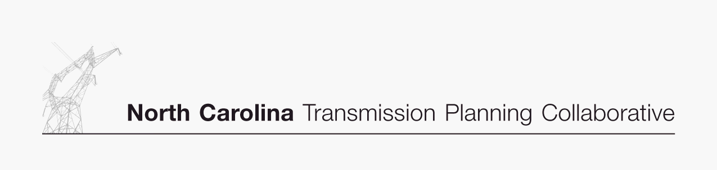

Appendix 1

Collaborative Transmission
Plan
Updated
Major Project Listing

DRAFT 03/16/07
Appendix 1 - Collaborative Transmission Plan – Updated Major Project Listing (Estimated Cost > $10M)
Project  ID | Reliability Project | Issue Resolved | Status¹ | Transmission  Owner | Planned In-Service Date | Estimated Cost  ($M) | Estimated Time to Complete (Years)
0001 | Marion-Whiteville 230 kV Line,  Establish a new 230 kV line initially operated at 115 kV | Address loading on Marion-Whiteville 115 kV | Underway | Progress | 6/1/2007 | $11 | 0.5
0002 | Lee Sub-Wommack 230 kV South Line, Reconductor existing line | Address loading on Lee-Wommack 230 kV South Line | Underway | Progress | 5/1/2008 | $13 | 1.5
0003 | Durham 500 kV Sub,  Establish 500 kV at Durham & loop-in the Mayo Plant-Wake 500 kV Line | Address loading on Wake 500/230 kV transformers | Underway | Progress | 6/1/2008 | $31 | 1.5
0004 | Clinton-Lee 230 kV Line,  Construct new line | Address loading on Clinton-Vander 115 kV line & Lee Sub-Wallace 115 kV Line | Underway | Progress | 6/1/2009 | $21 | 2.5
0005 | Rockingham-West End 230 kV Line,  Construct Wadesboro Bowman School 230 kV Tap & uprate the portion between the tap & Rockingham 230 kV Sub | Address loading on Rockingham-Blewett-Tillery 115 kV corridor | Underway | Progress | 6/1/2009 | $13 | 2.5
0006 | Cape Fear-Siler City 230 kV Line,  Construct new 230 kV line | Address voltage in the Asheboro area | Deferred² | Progress
0007 | Richmond 500 kV Substation,  Install 500 kV series reactor in Richmond-Newport 500 kV Line | Address large post contingency phase angle differences at times of high 500 kV flow | Underway | Progress | 6/1/2010 | $15 | 3.5
0008 | Greenville-Kinston Dupont 230 kV Line,  Construct new 230 kV line | Address loading on Greenville-Everetts 230 kV Line | Underway | Progress | 6/1/2011 | $18 | 4.0
0009 | Henderson-Kerr Dam 115 kV Line,  Construct new Warrenton 115 kV Tap & add line switches providing alternate service to Warrenton area | Address voltage in Warrenton area | Underway | Progress | 6/1/2011 | $10 | 4.0
0010 | Rockingham-West End 230 kV East Line,  Construct new 230 kV line | Address loading on Rockingham-West End 230 kV Line | Underway | Progress | 6/1/2011 | $33 | 4.5
0010A | Harris-RTP 230 kV Line,  Construct new 230 kV line | Address the need for new transmission source to serve rapidly growing load in the western Wake County area. | Underway | Progress | 6/1/2011 | $30 | 4.0

Appendix 1 - Collaborative Transmission Plan (Continued) – Updated Major Project Listing (Estimated Cost > $10M)
Project  ID | Reliability Project | Issue Resolved | Status¹ | Transmission  Owner | Planned In-Service Date | Estimated Cost  ($M) | Estimated Time to Complete  (Years)
0010B | Pleasant Garden-Asheboro 230 kV Line and Replace Asheboro 230/115 kV transformers,  Construct new 230 kV line | Address loadings on Badin/Tillery/Asheboro 115 kV corridor, Rockingham/Oakboro corridor, Durham/RTP corridor and voltage in the Asheboro area. Defers need for Cape Fear-Siler City 230 kV line out of the 10 year plan. | Planned | Progress  &  Duke | 6/1/2011⁵ | $29 | 5.0
0011 | Asheville-Enka 230 kV Line,  Construct new 230 kV line & establish 230 kV at Enka 115 kV | Address Asheville 230 kV transformer loading | Underway | Progress | 12/1/2011⁵ | $15 | 5.0
0012 | Buck-Asheboro 230 kV Line,  Construct new 230 kV interconnection | Address loadings on Badin-Tillery-Biscoe-Asheboro 115 kV corridor and Rockingham-Lilesville 230 kV Lines. Delays need for Cape Fear-Siler City 230 kV line and Harris-Durham 230 kV line. | Deleted³ | Progress  &  Duke
0013 | Replace Antioch 500/230 kV transformers #1 & #2 | Contingency loading of the remaining Antioch bank on loss of the parallel bank | Planned | Duke | 6/1/2013 | $30 | 5.0
0014 | Reconductor London Creek 230 kV Lines  (Peach Valley-Riverview #1 & #2) | Contingency loading of the remaining line on loss of the parallel line when an Oconee unit is off line | Planned | Duke | 6/1/2015 | $25 | 3.0
0015 | Harris-Durham 230 kV Line | Address loading on Cary Regency Park-Durham 230 kV Line | Deleted⁴ | Progress
0016 | Wake 500 kV Sub,  Install #3 500/230 kV Bank | Address loading on banks #1 & #2 | Deferred² | Progress

¹ Status:

Underway: Projects with this status range from the Transmission Owner having some money in its current year budget for the project to the Transmission Owner having completed some construction activities for the project.

Planned: Projects with this status do not have money in the Transmission Owner’s current year budget; and the project is subject to change.

² Project 0010B defers the need for Projects 0006 and 0016 to beyond the 10 year planning horizon.

³ Project 0010B deletes the need for Project 0012.

⁴ Project 0010A replaces Project 0015 because the RTP to Durham 230 kV portion of Project 0015 is not needed within the planning horizon.

⁵ Projects with a 5 year lead time and a planned in-service date of 2011 may be difficult to achieve before 2012.

