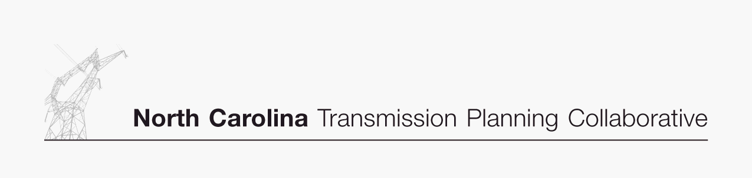

DRAFT
Transmission Advisory Group (TAG)
Agenda
January 25, 2007
ElectriCities Office
1427 Meadow Wood Boulevard
Raleigh, North Carolina
10:00 AM EST

- Administrative Items
- Introductions
- Review meeting protocol and logistics
- Additional Agenda Items

- 2006 NC Transmission Planning Collaborative (NCTPC) DRAFT Transmission Plan Report
- Receive an overview presentation on the 2006 NCTPC DRAFT Transmission Plan Report
- Provide comments to the OSC on the 2006 NCTPC Transmission Plan
- Provide feedback to the OSC on the 2006 NCTPC Process

- 2007 NCTPC Study Scope
- Receive an overview on the 2007 NCTPC Study Scope

- 2007 Enhanced Transmission Access Planning Process Input from the TAG
- Discuss the requested TAG input for transaction scenarios and interfaces for analysis in the 2007 Enhanced Transmission Access Planning Process
- Establish deadline for providing TAG input to the OSC

- 2007 TAG Activity Schedule
- Review and provide comments on the proposed 2007 TAG Activity Schedule

- TAG Open Forum
- Discuss any items relevant to the NCTPC Process

