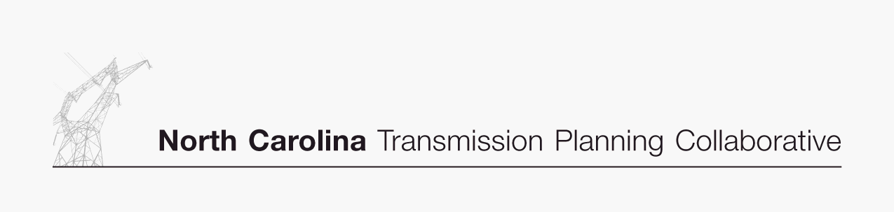

Appendix B

Collaborative Transmission
Plan
Major Project Listing

DRAFT 12/14/06

Collaborative Transmission Plan – Major Project Listing (Estimated Cost > $10M)
Project  ID | Reliability Project | Issue Resolved | Status¹ | Transmission  Owner | Projected In-Service Date | Estimated Cost  ($M) | Project Lead  Time (Years)
0001 | Marion-Whiteville 230 kV Line,  Establish a new 230 kV line initially operated at 115 kV | Address loading on Marion-Whiteville 115 kV | Under Construction | Progress | 6/1/2007 | $11 | 5
0002 | Lee Sub-Wommack 230 kV South Line, Reconductor existing line | Address loading on Lee-Wommack 230 kV South Line | Under Construction | Progress | 5/1/2008 | $13 | 5
0003 | Durham 500 kV Sub,  Establish 500 kV at Durham & loop-in the Mayo Plant-Wake 500 kV Line | Address loading on Wake 500/230 kV transformers | Under Construction | Progress | 6/1/2008 | $31 | 5
0004 | Clinton-Lee 230 kV Line,  Construct new line | Address loading on Clinton-Vander 115 kV line & Lee Sub-Wallace 115 kV Line | Committed | Progress | 6/1/2009 | $21 | 5
0005 | Rockingham-West End 230 kV Line,  Construct Wadesboro Bowman School 230 kV Tap & uprate the portion between the tap & Rockingham 230 kV Sub | Address loading on Rockingham-Blewett-Tillery 115 kV corridor | Committed | Progress | 6/1/2009 | $13 | 5
0006 | Cape Fear-Siler City 230 kV Line,  Construct new 230 kV line | Address voltage in the Asheboro area | Planned | Progress | 6/1/2010 | $19 | 5
0007 | Richmond 500 kV Substation,  Install 500 kV series reactor in Richmond-Newport 500 kV Line | Address large post contingency phase angle differences at times of high 500 kV flow | Planned | Progress | 6/1/2010 | $15 | 4
0008 | Greenville-Kinston Dupont 230 kV Line,  Construct new 230 kV line | Address loading on Greenville-Everetts 230 kV Line | Committed | Progress | 6/1/2011 | $18 | 5
0009 | Henderson-Kerr Dam 115 kV Line,  Construct new Warrenton 115 kV Tap & add line switches providing alternate service to Warrenton area | Address voltage in Warrenton area | Committed | Progress | 6/1/2011 | $10 | 5
0010 | Rockingham-West End 230 kV East Line,  Construct new 230 kV line | Address loading on Rockingham-West End 230 kV Line | Committed | Progress | 6/1/2011 | $33 | 5

Collaborative Transmission Plan (Continued) – Major Project Listing (Estimated Cost > $10M)
Project  ID | Reliability Project | Issue Resolved | Status¹ | Transmission  Owner | Projected In-Service Date | Estimated Cost  ($M) | Project Lead  Time (Years)
0011 | Asheville-Enka 230 kV Line,  Construct new 230 kV line & establish 230 kV at Enka 115 kV | Address Asheville 230 kV transformer loading | Proposed | Progress | 12/1/2011 | $15 | 5
0012 | Buck-Asheboro 230 kV Line,  Construct new 230 kV interconnection | Address loadings on Badin-Tillery-Biscoe-Asheboro 115 kV corridor and Rockingham-Lilesville 230 kV Lines. Delays need for Cape Fear-Siler City 230 kV line and Harris-Durham 230 kV line. | Proposed | Progress  &  Duke | 6/1/2014 | $40 | 6
0013 | Replace Antioch 500/230 kV transformers #1 & #2 | Contingency loading of the remaining Antioch bank on loss of the parallel bank | Proposed | Duke | 2014 | $30 | 5
0014 | Reconductor London Creek 230 kV Lines  (Peach Valley-Riverview #1 & #2) | Contingency loading of the remaining line on loss of the parallel line when an Oconee unit is off line | Proposed | Duke | 2015 | $25 | 3
0015 | Harris-Durham 230 kV Line | Address loading on Cary Regency Park-Durham 230 kV Line | Proposed | Progress | 6/1/2016 | $88 | 5
0016 | Wake 500 kV Sub,  Install #3 500/230 kV Bank | Address loading on banks #1 & #2 | Proposed | Progress | 6/1/2016 | $21 | 5

- Status: In Service – transmission facility is commissioned and in service.

Under Construction – the transmission owner has completed Right of Way (“ROW”) acquisition, siting and permitting; the transmission owner is in the process of ordering equipment and hiring a contractor; or the transmission facility is actually under construction.

Committed – the project has some money in the transmission owner’s budget for the current fiscal year for ROW acquisition, detailed design, surveys, geotechnical studies, siting and permitting efforts.

Planned – the project is (i) within the first 5 year window or (ii) within the 10 year planning horizon and the project has a longer lead time that would require spending in the near term to be completed in time to address the reliability issue. However, the project is not in the transmission owner’s budget for the current fiscal year yet. The project is subject to change, but, there is more confidence in the implementation of the planned project than in a proposed or conceptual project.

Proposed – the project is within the 6-10 year window of the 10 year planning horizon and is not budgeted yet, and is subject to significant change.

Concept – the project is a high level concept for addressing issues related to resource supply options, or issues beyond the 10 year planning horizon.

