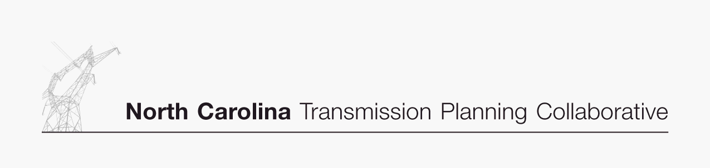

Appendix B

Collaborative Transmission
Plan
Project Listing

DRAFT 11/22/06

Collaborative Transmission Plan
Project  ID | Reliability Project | Issue Resolved | Status | TO | Projected In-Service Date | Estimated Cost  ($M) | Project Lead  Time (Years)
0001 | Marion-Whiteville 230 kV Line,  Establish a new 230 kV line initially operated at 115 kV | Address loading on Marion-Whiteville 115 kV | Under Construction | PEC | 6/1/2007 | $11 | 5
0002 | Lee Sub-Wommack 230 kV South Line, Reconductor existing line | Address loading on Lee-Wommack 230 kV South line | Under Construction | PEC | 5/1/2008 | $13 | 5
0003 | Durham 500 kV Sub,  Establish 500 kV at Durham & loop-in the Mayo Plant-Wake 500 kV Line | Address loading on Wake 500/230 kV transformers | Under Construction | PEC | 6/1/2008 | $31 | 5
0004 | Clinton-Lee 230 kV Line,  Construct new line | Address loading on Clinton-Vander 115 kV line & Lee Sub-Wallace 115 kV line | Committed | PEC | 6/1/2009 | $21 | 5
0005 | Rockingham-West End 230 kV Line,  Construct Wadesboro Bowman School 230 kV Tap & uprate the portion between the tap & Rockingham 230 kV Sub | Address loading on Rockingham-Blewett-Tillery 115 kV corridor | Committed | PEC | 6/1/2009 | $13 | 5
0006 | Apex US1-Amberly 115 kV Feeder,  Extend current 115 kV feeder by constructing the Green Level-Amberly 115 kV section | Load serving | Committed | PEC | 6/1/2010 | $20 | 5
0007 | Cape Fear-Siler City 230 kV Line,  Construct new 230 kV line | Address voltage in the Asheboro area | Committed | PEC | 6/1/2010 | $19 | 5
0008 | Greenville-Kinston Dupont 230 kV Line,  Construct new 230 kV line | Address loading on Greenville-Everetts 230 kV line | Committed | PEC | 6/1/2011 | $18 | 5
0009 | Henderson-Kerr Dam 115 kV Line,  Construct new Warrenton 115 kV Tap & add line switches providing alternate service to Warrenton area | Address voltage in Warrenton area | Committed | PEC | 6/1/2011 | $10 | 5
0010 | Rockingham-West End 230 kV East Line,  Construct new 230 kV line | Address loading on Rockingham-West End 230 kV line | Committed | PEC | 6/1/2011 | $33 | 5

Collaborative Transmission Plan (Continued)
Project  ID | Reliability Project | Issue Resolved | Status | TO | Projected In-Service Date | Estimated Cost  ($M) | Project Lead  Time (Years)
0011 | Asheville-Enka 230 kV line,  Construct new 230 kV line & establish 230 kV at Enka 115 kV | Address Asheville 230 kV transformer loading | Proposed | PEC | 12/1/2011 | $15 | 5
0012 | Apex US1-RTP 115 kV Line,  Develop RTP 230/115 kV Sub & construct Amberly-RTP 115 kV section establising a new 115 kV line | Load serving | Proposed | PEC | 6/1/2012 | $11 | 5
 | Harris-Durham 230 kV Line | Address loading on CRP-Durham 230 kV Line | Proposed | PEC | 6/1/2014 | $77 | 5
 | Bucks-Asheboro 230 kV Line,  Construct new 230 kV interconnection | Address loadings on Tillery-Biscoe-Asheboro 115 kV corridor, Rockingham-Anson 230 kV Lines, Cape Fear-Siler City 230 kV line | Proposed | PEC | 6/1/2014 | $50 | 6
0013 | Replace Antioch 500/230 kV transformers #1 & #2 | Contingency loading of the remaining Antioch bank on loss of the parallel bank | Proposed | Duke | 2014 | $20 to $30 | 5
0014 | Reconductor London Creek 230 kV lines  (Peach Valley - Riverview #1 & #2) | Contingency loading of the remaining line on loss of the parallel line when an Oconee unit is off line | Proposed | Duke | 2015 | $20 to $25 | 3
 | Wake 500 kV Sub,  Install #3 500/230 kV Bank | Address loading on banks #1 & #2 | Proposed | PEC | 6/1/2016 | $21 | 5

