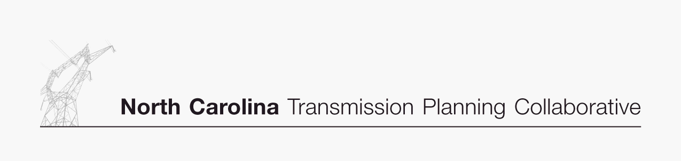

Appendix A

Interchange Tables

DRAFT 11/22/06

2011 SUMMER PEAK
DUKE ENERGY CAROLINAS
DETAILED INTERCHANGE

Duke Energy Carolinas Scheduled Imports/Purchases

Base Case PEC TRM Case
CPLE (NCEMC) 200 MW 0 MW
CPLE (City of Seneca) 31 MW 31 MW
PJM (NCMPA) 40 MW 40 MW
SCEG (City of Greenwood) 57 MW 57 MW
SCEG (NCEMC) 100 MW 100 MW
SCPSA (New Horizons/NHEC) 880 MW 880 MW
SEPA (Hartwell) 156 MW 156 MW
SEPA (Thurmond) 113 MW 113 MW
SOCO (PMPA) 180 MW 180 MW
Total 1757 MW 1557 MW

Duke Energy Carolinas Scheduled Exports/Sales

Base Case PEC TRM Case
CIN 350 MW 350 MW
CPLE (Broad River) 850 MW 850 MW
CPLE (Lincoln) 50 MW 50 MW
CPLE (NCEMC) 100 MW 100 MW
CPLE (PEC TRM VACAR Reserves) 0 MW 506 MW
TVA 200 MW 200 MW
Total 1550 MW 2056 MW

Duke Energy Carolinas Net Interchange -207 MW 499 MW

Note:
Positive net interchange indicates an export and negative interchange an import.
2011 SUMMER PEAK
PROGRESS ENERGY CAROLINAS (EAST)
DETAILED INTERCHANGE

Progress Energy Carolinas (East) Scheduled Imports/Purchases

Base Case PEC TRM Case
AEP (NCEMC) 305 MW 305 MW
AEP (PEC TRM) 0 MW 97 MW
AEP (Rockport) 250 MW 250 MW
CPLW 0 MW 150 MW
DUKE 50 MW 50 MW
DUKE (Broad River) 850 MW 850 MW
DUKE (NCEMC in Duke) 100 MW 100 MW
DUKE (PEC TRM VACAR Reserves) 0 MW 506 MW
DVP (3 Towns plus Sharping) 20 MW 20 MW
DVP (PEC TRM) 0 MW 836 MW
DVP (SEPA-KERR) 95 MW 95 MW
SCEG (NCEMC) 150 MW 150 MW
SCEG (PEC TRM) 0 MW 200 MW
SCPSA (Co-Gen) 9 MW 9 MW
SCPSA (PEC TRM) 0 MW 196 MW
SOCO (NCEMC) 25 MW 25 MW
Total 1854 MW 3839 MW

Progress Energy Carolinas (East) Scheduled Exports/Sales

Base Case PEC TRM Case
CPLW 50 MW 0 MW
DUKE (City of Seneca) 31 MW 31 MW
DUKE (EMC) 200 MW 0 MW
DVP (Littleton) 9 MW 9 MW
DVP (NCEMPA) 165 MW 165 MW
Total 455 MW 205 MW

Progress Energy Carolinas (East) Net Interchange -1399 MW -3634 MW

Note:
Positive net interchange indicates an export and negative interchange an import.

2011 SUMMER PEAK
PROGRESS ENERGY CAROLINAS (WEST)
DETAILED INTERCHANGE

Progress Energy Carolinas (West) Scheduled Imports/Purchases

Base Case PEC TRM Case
CPLE 50 MW 0 MW
TVA 14 MW 14 MW
Total 64 MW 0 MW

Progress Energy Carolinas (West) Scheduled Exports/Sales

Base Case PEC TRM Case
CPLE 0 MW 150 MW
Total 0 MW 150 MW

Progress Energy Carolinas (West) Net Interchange -64 MW 136 MW

Note:
Positive net interchange indicates an export and negative interchange an import.
2010-11 WINTER PEAK
DUKE ENERGY CAROLINAS
DETAILED INTERCHANGE

Duke Energy Carolinas Scheduled Imports/Purchases

Base Case PEC TRM Case
CPLE (NCEMC) 100 MW 100 MW
CPLE (City of Seneca) 22 MW 22 MW
SCEG (City of Greenwood) 40 MW 40 MW
SCEG (NCEMC) 60 MW 60 MW
SCPSA (New Horizons/NHEC) 859 MW 859 MW
SEPA (Hartwell) 156 MW 156 MW
SEPA (Thurmond) 113 MW 113 MW
SOCO (PMPA) 61 MW 61 MW
Total 1411 MW 1411 MW

Duke Energy Carolinas Scheduled Exports/Sales

Base Case PEC TRM Case
CIN 350 MW 350 MW
CPLE (Broad River) 850 MW 850 MW
CPLE (NCEMC) 100 MW 100 MW
CPLW (PEC TRM VACAR Reserves) 0 MW 200 MW
TVA 200 MW 200 MW
Total 1500 MW 1700 MW

Duke Energy Carolinas Net Interchange 89 MW 289 MW

Note:
Positive net interchange indicates an export and negative interchange an import.
2010-11 WINTER PEAK
PROGRESS ENERGY CAROLINAS (EAST)
DETAILED INTERCHANGE

Progress Energy Carolinas (East) Scheduled Imports/Purchases

Base Case PEC TRM Case
AEP (NCEMC) 305 MW 305 MW
AEP (Rockport) 250 MW 0 MW
DUKE (Broad River) 850 MW 850 MW
DUKE (NCEMC in Duke) 100 MW 100 MW
DVP (3 Towns plus Sharping) 20 MW 20 MW
DVP (SEPA-KERR) 95 MW 95 MW
FPC 50 MW 50 MW
SCEG (NCEMC) 150 MW 150 MW
SCPSA (Co-Gen) 9 MW 9 MW
SOCO (NCEMC) 25 MW 25 MW
Total 1854 MW 1604 MW

Progress Energy Carolinas (East) Scheduled Exports/Sales

Base Case PEC TRM Case
CPLW 120 MW 100 MW
DUKE (City of Seneca) 22 MW 22 MW
DUKE (EMC) 100 MW 100 MW
DVP (Littleton) 9 MW 9 MW
DVP (NCEMPA) 142 MW 142 MW
Total 393 MW 373 MW

Progress Energy Carolinas (East) Net Interchange -1461 MW -1231 MW

Note:
Positive net interchange indicates an export and negative interchange an import.

2010-11 WINTER PEAK
PROGRESS ENERGY CAROLINAS (WEST)
DETAILED INTERCHANGE

Progress Energy Carolinas (West) Scheduled Imports/Purchases

Base Case PEC TRM Case
AEP (Rockport) 0 MW 250 MW
AEP (PEC TRM) 0 MW 42 MW
CPLE 120 MW 100 MW
DUKE (PEC TRM VACAR Reserves) 0 MW 200 MW
TVA 14 MW 14 MW
Total 134 MW 606 MW

Progress Energy Carolinas (West) Scheduled Exports/Sales

Base Case PEC TRM Case
None Scheduled 0 MW 0 MW
Total 0 MW 0 MW

Progress Energy Carolinas (West) Net Interchange -134 MW -606 MW

Note:
Positive net interchange indicates an export and negative interchange an import.

